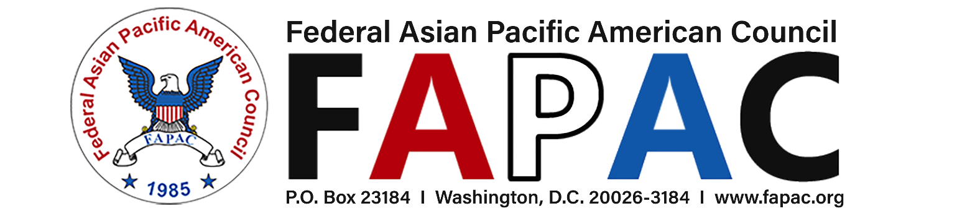

“Promoting Equal Opportunity and Cultural Diversity for APAs in Government”

2022 FAPAC Career Development Program (CDP) – Level I
2022 APPLICATION FORM

It is the policy of FAPAC to provide equal opportunities without regard to race, color, religion, national origin, gender, sexual orientation, age, or disability. Applicants must be able to participate in all CDP activities and commit to the entire duration of the program (March to September 2022). The Orientation will be held virtually, and the Leadership Training sessions will be held virtually during the FAPAC National Leadership Training Program (NLTP) in May 2022.

Application form and resume are due by 5:00pm EST on Friday April 8, 2022
Click here for online application (This is a fillable form)

Application Information:
* I am applying as a: ☐Mentor (GS-14 or higher) ☐Mentee (GS-12 or lower)

First Name: Click here to enter text. Last Name: Click here to enter text. MI: Click here to enter text.
Street Address: Click here to enter text. Apartment/Unit#: Click here to enter text.
City: Click here to enter text. State: Click here to enter text. Postal Code: Click here to enter text.
Primary Phone Number: Click here to enter text. Secondary Phone Number: Click here to enter text.
Email Address: Click here to enter text. Secondary Email Address: Click here to enter text.

Are you a FAPAC Member?
☐ Yes, I am a regular member of FAPAC.
Name of FAPAC Chapter: Click here to enter text.
☐ Yes, I am a lifetime FAPAC member.
☐ No, I am not a FAPAC member.
☐ I intend to join FAPAC (https://fapac.org/joinmembership).
* Active FAPAC Members will have preference during the CDP selection process

Education Background:
Highest Degree obtained: Click here to enter text. Graduation Date: Click here to enter text.
Major: Click here to enter text. Minor: Click here to enter text.
Certifications: Click here to enter text. Licenses: Click here to enter text.
Other Training: Click here to enter text.

Professional Experiences:
Current Employer: Click here to enter text.
Position Title: Click here to enter text. Is this a supervisory position? Choose an item.
Grade & Step: Click here to enter text. Series: Click here to enter text.

Major Duties/Expertise: Click here to enter text.
Year of Professional Experience: Click here to enter text.
If the above list does not apply, please describe: Click here to enter text.

Volunteer/Committee Experiences:
Indicate your community service or volunteer experiences.
Organization: Click here to enter text.
Role: Click here to enter text.
Responsibilities: Click here to enter text.
Years of Volunteer Experience: Click here to enter text.

Demographic Information (optional for statistical purposes):
Gender: Click here to enter text.
Ethnicity (Origin): Click here to enter text.

Personal Goals:
Which goals are you considering as you join the 2022 Career Development Program Level I?
☐ Change of Career Path
☐ Career Advancement Planning
☐ Leadership/Management Training
☐ Personal Development/Self-Improvement (beliefs/values)
☐ Networking & Personal Branding
☐ Other (specify): Click here to enter text.

Please briefly describe what your aspirations and goals in this program (Answer each question in 200 words or less).

1. What do you expect to gain from participating in the Career Development Program as a Mentee/Mentor?
Click here to enter text.

2. How do you envision yourself contributing to the overall program success?
Click here to enter text.

* Please submit your resume (2 pages Max.) as an attachment
PERSONAL PREFERENCES:

Which mentoring method(s) do you prefer?
☐ One on one
☐ Group mentoring
☐ In-person mentoring
☐ Remote mentoring
(by phone or online video)
☐ No preference

Would you prefer to have a Mentor/Mentee of the same gender or different gender?
☐ Same gender
☐ Different gender
☐ No preference

FOR MENTEES ONLY:
Would you prefer to have a mentor from a different professional field?
☐ Yes, please match me with someone outside of my field
☐ No, I prefer a mentor from the same field
☐ No preference

FOR MENTORS ONLY:
a. Do you possess: ☐ 5+ years of working experience in a federal supervisory capacity?
☐ 8+ years of working experience in federal sector?

b. Are you interested in becoming a FAPAC workshop presenter or a facilitator for future FAPAC events? ☐ Yes ☐ No

AGREEMENT/SIGNATURE

By submitting this application, I affirm that the facts set forth are true and complete. If accepted, I am committed to meeting the program requirements as presented. I understand that FAPAC reserves the right to assign participants according to individual circumstances, but final assignments are subject to a variety of factors, i.e. agency support, individual preferences, and availability of mentors/mentees. I authorize FAPAC to use the provided data for Career Development Program purposes.

Signature: Date: Date:

Click here for online application
or submit this application form and resume via email to cdp@fapac.org
by 5:00pm EST on Friday April 8, 2022.

