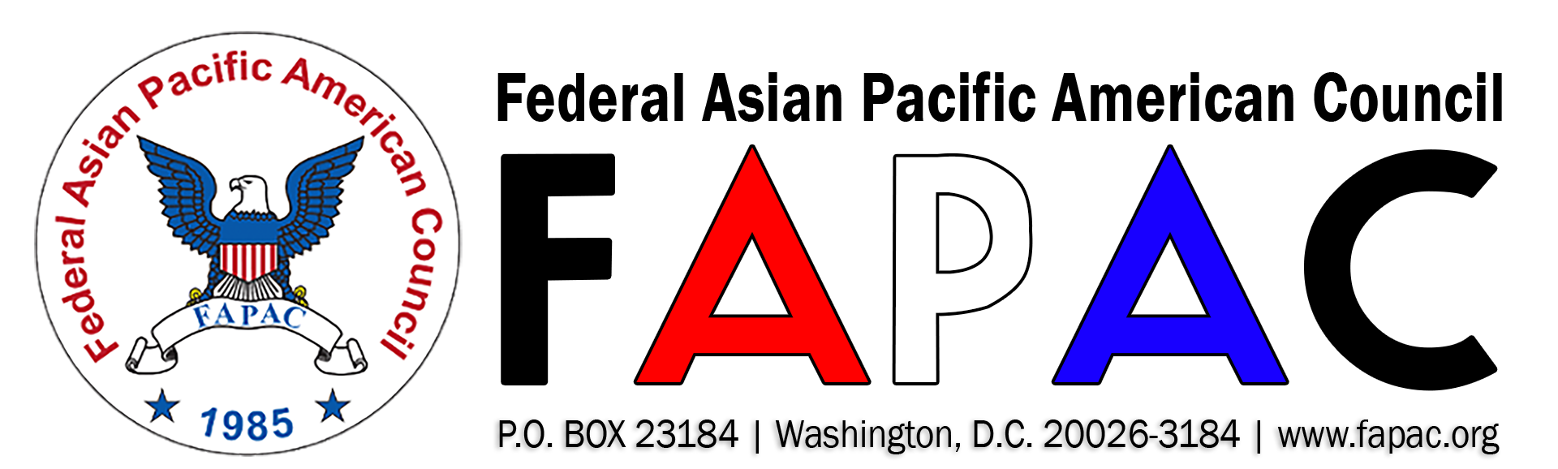

“Promoting Equal Opportunity and Cultural Diversity for APAs in Government”
2020 FAPAC CAREER DEVELOPMENT MENTORING PROGRAM (CDP) ANNOUNCEMENT

The Federal Asian Pacific American Council (FAPAC) is now accepting applications for its 2020 Career Development Mentoring Program (CDP) for High Performers. The program begins March 2020 through September 2020. Training sessions will be held in the Washington, DC metro area.
The CDP is a tuition-free program that offers individual mentoring, professional development, and career counseling for high-performing federal DOD, Non-DOD and District of Columbia employees. Forty participants will be selected for the 2020 CDP (20 mentors and 20 mentees).

Mentoring objectives include:
- Connecting with a diverse network of dedicated public servants;
- Strengthening personal goals and career planning;
- Training in leadership competencies; and,
- Access to career advancement workshops.

Who May Apply:
- Current Federal or District of Columbia government employees and military personnel with permanent career status.
- Mentee candidates must be GS-13 or lower.
- Mentor candidates must be GS-14 or higher with at least 3 years of working experience in supervisory or in a leadership capacity and 8+ years in federal service.

Application Requirements:
- Resume (no more than 3 pages)
- Completed 2020 FAPAC Career Development Program Application Form
Submit completed applications by email to mentoring@fapac.org by Friday, January 31, 2020 at 5:00 pm EDT. Late or incomplete applications will not be considered and marked ineligible. For more information, visit http://www.fapac.org/cdp or contact 2020 FAPAC Program Committee Co-Chairs Phuong Callaway and Cynthia Dunn at mentoring@fapac.org.

