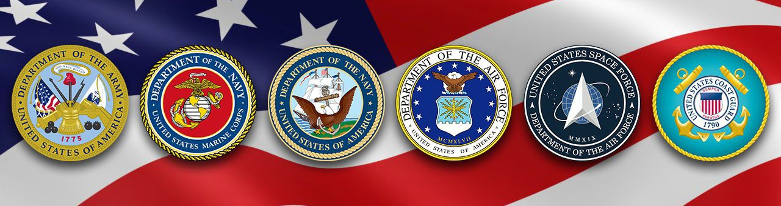

Veterans Program
The Federal Asian Pacific American Council (FAPAC), in partnership with the Department of Veterans Affairs, is hosting workshops on Veterans benefits, services, and employment. Veterans, Active-Duty Personnel, and their families are invited to attend. Attendees will have all-day access to the Exhibitor Booths (9:00am – 5:00pm), workshops, and networking opportunities throughout the day. Register for this FREE event today.

When: Wednesday, May 10, 2023
Time: 1:30pm – 3:00pm
Where: Westin Long Beach – 333 E. Ocean Blvd, Long Beach CA 90802
Register: https://fapac.org/veterans2023

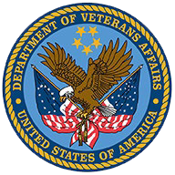
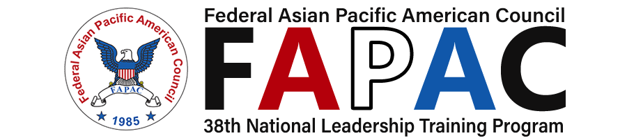

Questions? Contact nltp@fapac.org.

